**Prediction Analysis of Coffee Prices**

Simon Atehortua

ID 501094927

Data Analytics, Big data, and Predictive Analytics, Toronto Metropolitan University

CIND 820D1H: Big Data Analytics Project

Prof. I. M. Smart

Due date

# Abstract

Coffee, one of the greatest drinks that humanity could have ever discovered. Prices of coffee are expressed in US cents per pound of green coffe and many factors affect the prices, the ICO (International Coffee Organization), will collect daily prices from the New York, Germany and France futures exchanges and will set up a price based in these factors.

The idea after doing an exploratory analysis of the data, is to predict the prices of the ICO market given the prices of the markets in Europe and USA of a variety of Coffees.

The following tools will be used during the project for analysis: Microsoft Excel, Python, Jupiter Notebooks and Different Machine Learning (ML) algorithms will be used: Linear Regression , KNN Regressor, SVM (Suport Vector Machine) and Neural Networks.

The data comes from the Colombian National Coffe Growers (Federacion Nacional De Cafeteros de Colombia), the national entity responsable for exporting coffee in Colombia, the website (https://federaciondecafeteros.org/wp/coffee-statistics/?lang=en) has the necessary files with this information.

The coffee is divided into 4 Groups, each group has 1 or more different kinds of coffee, as seen in Table 1.

**Table 1**

*Table of Coffee Groups and Grouth of coffe*

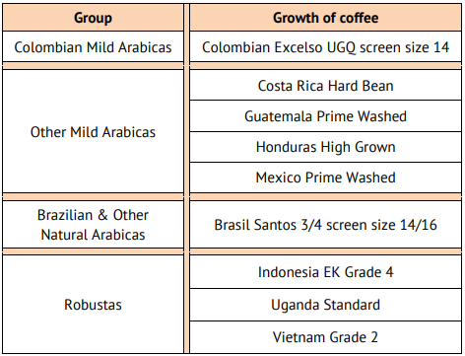

Which is the most accurate algorithm to predict the ICO prices? What will be a future price given that the model has been properly trained? Why is this investigation relevant to the student? These are some of the questions that are planning to be solved with these project among more questions that will come alng the development of the project

# 

# 

# Your Full Title of Your Paper

The title of your paper should summarize the main idea of your paper and identify the variables or issues under investigation and the relationship between them. Keep the title as succinct as possible, but include essential terms that will make your topic known to the reader.

Start each paragraph of the body of your paper indented with one tab key (1/2 inch). Use one inch margins on all sides. Double-space throughout your paper. Do not add a space between paragraphs. Only add one space after punctuation at the end of a sentence.

APA has expanded the fonts that are acceptable for student papers. You can choose 12-point Times New Roman or 11-point Georgia for hard copy papers, or 11-point Arial or 11-point Calibri 11 for papers to be read electronically. For computer code, APA suggests using 10-point Lucida Console or 10-point Courier New. Use the same font throughout your paper.

There are up to 5 levels of headings in APA Style papers. All headings use title case (major words are capitalized). The first level is used to break up your paper into major portions. First level headings are centered and bolded. Second level headings are flush left and use a bold font. Level 3 headings are flush left and use bold italics. Level 4 headings are indented one tab, bold font, and end with a period. The text begins on the same line and continues as a regular paragraph for Level 4 headings. Level 5 headings are similar to Level 4, but use bold italics.

Insert a page break at the end of the body of your paper to start a new page for the Reference list. The reference list includes citations for all recoverable sources cited in the body of your paper. Personal communications, such as private letters or interviews, or non-recorded events are not included. References should be alphabetized, and use a hanging indent.

# 

# References

Statistics Committee. (2021, March 29). sc-106e-rules-indicator-prices.pdf. London; International Coffee Organization.